Paper Title – Can Extend Over Two Lines If Required  
Format: J-Titel

Author 1

Department XY

University   
Street No

ZIP City

E-Mail: [aaa@bbb](mailto:Norbert.Ketterer@cs.hs-fulda.de)

Author 2

Department XY

University  
Street No

ZIP City

E-Mail: [aaa@bbb](mailto:Norbert.Ketterer@cs.hs-fulda.de)

Author 3

Department XY

University  
Street No

ZIP City

E-Mail: [aaa@bbb](mailto:Norbert.Ketterer@cs.hs-fulda.de)

ABSTRACT – Format J-Überschrift 1

Here we expect an Abstract in Format J-Text

KEYWORDS– J-Überschrift 1

Keyword 1, Keyword 2, … im Format J-Text

MAJOR HEADINGS – J-Überschrift 1

Here text will be places in format J-Text. In general all paragraphs use the format with prefix „J-“.

MAJOR HEADINGS – J-Überschrift 1

Subheadings– J-Überschrift 2

Secondary Subheadings– J-Überschrift 3

Here we see some Text with reference to Figure 1, which shows a picture with a caption.

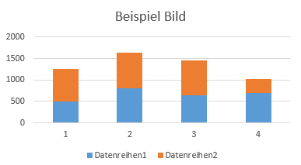

Figure 1: *Example of an integrated Diagram – Format J-Abbildung*

Here we have some text an an enumeration:

* Topic 1
* Topic 2

REFERENCES– J-Überschrift 1

Cordeau, Laporte, et. al. “Vehicle Routing”, aus Barnhart, Laporte (Eds.), Handb. in Operations Research & Management Science, Vol. 14, Chapter 6, Elsevier 2007

Toth, Vigo, “An Overview of Vehicle Routing Problems” aus Toth, Vigo (Ed.) The Vehicle Routing Problem, Siam, 2002

AUTHOR BIOGRAPHIES– J-Überschrift 1

Contactinformation/ brief biography